A
Major Project SRS
On
Intelligent Intrusion Detection System (IIDS)

Submitted in partial fulfillment of the requirements
For the award of the degree of

Bachelor of Technology
In
Computer Science and Engineering

By
Aryan Raj (CS-2341005)
Mayank Pandey (CS-23411223)
Anmol Priya (CS-23411322)
Aakar Singh (CS-23411058)
Navneet Kumar (CS-2341055)

Under the Supervision of
Mr. Mukesh Kumar
School of Computer Science and Engineering


IILM University
Greater Noida, Uttar Pradesh

INDEX
1.Introduction 1
1.1 Purpose 1
1.2 Scope 1
1.3 Definitions, Acronyms, and Abbreviations 2
1.4 References 2
2. Literature Review 4
3. General Description 6
3.1 Product Perspective 6
3.2 Product Functions 6
3.3 User Characteristics 7
3.4 General Constraints 8
3.5 Assumptions 9
3.6 Dependencies 10
4. Specific Requirements 12
4.1 External Interface Requirements 12
4.1.1 User Interfaces 12
4.1.2 Hardware Interfaces 12
4.1.3 Software Interfaces 12
4.1.4 Communications Interfaces 12
4.2 Functional Requirements 13
4.2.1 Network Traffic Input Acquisition 13
4.2.2 Data Validation and Preprocessing 13
4.2.3 Supervised Model Processing 14
4.2.4 Unsupervised Model Processing 14
4.2.5 Decision Module (Hybrid Fusion Engine) 15
4.2.6 Logging & Auditing 16
4.2.7 Alert & Notification Management 17
4.3 Non-Functional Requirements 17
4.3.1 Performance Requirements 17
4.3.2 Reliability and Availability 17
4.3.3 Security Requirements 18
4.3.4 Maintainability 18

1.Introduction

1.1 Purpose
The main focus of the Intelligent Intrusion Detection System (IIDS) is to close the significant gap that is present in traditional signature-based security systems, which have great difficulty in recognizing Zero-Day attacks. Transitions that reactive models, which utilize an up-to-date database of known threats, will take to move to a machine learning process, will ultimately hinder the ability to identify possible threats based on behavioral patterns outside of the database. This is an evolutionary necessity for contemporary network systems. Modern systems are being exploited for their previously undocumented vulnerabilities, which calls for a system that is capable of learning what is 'normal' for system traffic, and ultimately contravenes the system. In addition to this, IIDS is capable of resolving the traditional dilemma of speed of computation vs depth of detection by using a hybrid system design.
Implementing a form of Shallow Learning via Random Forest feeds a faster filtering system, enabling faster processing of data traffic streams, and the Deep Learning (CNN/LSTM) component improves the second layer of system processing to identify more complex, non-linear patterns of attack. This is a form of multi-layered systems architecture to ensure operational consistency and network support of advanced attack controls without requiring the operational support and speed of the system. Finally, the system is designed to support security practitioners with the actionable intelligence and fine-grained classifications. The IIDS system classifies intrusions into certain types, such as Denial of Service (DoS), Probe, User to Root (U2R), and Remote to Local (R2L). This enables administrators to allocate response activities in accordance with the seriousness of the threat. This type of system, when combined with the need for high accuracy and low false-positive rates, means that the system can be relied upon as an automated assistant, and will improve the security level for the organization overall.

1.2 Scope
The IIDS project's scope includes every step of the data pipeline, from network log analysis to threat visualization.

In Scope:
- Data Ingestion: Reading network traffic logs from the NSL-KDD dataset.
- Preprocessing: Cleaning data and converting categorical features (like TCP/UDP) into numerical format.
- Hybrid Analysis: A two-stage detection engine where traffic is classified as "Normal" or a specific attack type (DoS, Probe, U2R, R2L).
- Visualization: A web-based Admin Dashboard to display real-time threat levels.

Out of Scope:
- The IP addresses won't be automatically blocked by the system (Active Defense).
- It is a Passive Monitoring System that alerts the admin.
- Currently, IPv6 is not supported by the system, which is made for IPv4 traffic analysis.

1.3 Definitions, Acronyms, and Abbreviations
Term | Definition
IIDS | Intelligent Intrusion Detection System.
Hybrid ML | An architecture combining two or more algorithms (e.g., Random Forest + CNN) to improve accuracy.
False Positive | When the system incorrectly flags normal traffic as an attack (A false alarm).
NSL-KDD | The benchmark dataset used for training intrusion detection systems.
Zero-Day Attack | A new type of cyberattack that has never been seen before.
CNN | Convolutional Neural Network (Used here for Deep Learning).

1.4 References
Comparative Analysis of Random Forest on NSL-KDD
- Summary: A benchmark study focusing on the NSL-KDD dataset. It identifies Random Forest as a "top performer" due to its balance between high detection capability and reliability, specifically for the attack categories (DoS, Probe, etc.) you've listed.
- DOI: 10.1016/j.procs.2016.06.047
Two-Tier Stacking for Zero-Day Attack Detection
- Summary: This reference justifies your "Product Perspective" of using a hybrid model to catch Zero-Day attacks. It uses a two-tiered approach that combines unsupervised and supervised learning to retain high precision for known attacks while spotting new ones.
- DOI: 10.1109/ACCESS.2020.3016462
IDRandom-Forest: Advanced Random Forest for Real-Time Intrusion Detection
- Summary: A 2024 IEEE Access publication that introduces an advanced Random Forest technique to resolve latency issues in real-time traffic. It provides a strong justification for why you chose Random Forest to handle the "speed" aspect of your hybrid system while maintaining high accuracy.
- DOI: 10.1109/ACCESS.2024.3444218
Optimizing IDS with Hybrid Random Forest and CNN-LSTM Models
- Summary: This 2025 paper directly addresses your goal of enhancing accuracy and efficiency. It compares standalone Random Forest models with a hybrid CNN-LSTM-RF model, reporting superior performance in detecting complex data patterns in network traffic.
- DOI: 10.3929/ethz-b-000676755
AI-Powered Intrusion Detection Using CNN-LSTM for Cloud and Edge Networks
- Summary: This 2025 study explores the use of CNN-LSTM architectures specifically for identifying hierarchical and sequential patterns in NSL-KDD data. It discusses the model's ability to minimize false alarms and its scalability for real-time traffic monitoring.
- DOI: 10.31224/osf.io/y9v2s

2. Literature Review
The development of the Intelligent Intrusion Detection System (IIDS) is situated at the intersection of traditional machine learning and modern deep learning. This section provides a comprehensive review of the research that validates the use of the NSL-KDD dataset, the implementation of Random Forest for real-time speed, and the integration of CNN-LSTM for detecting complex, sequential attack patterns.
2.1 Benchmarking and Dataset Validation: The NSL-KDD Standard
The foundation of any robust IDS is the quality of its training data. Research conducted by Belavagi and Munivannahalli (2016) provides a definitive benchmark for the NSL-KDD dataset, which remains the industry standard for evaluating intrusion detection models. Their study highlights that while many algorithms struggle with varied traffic, Random Forest emerges as a "top performer" due to its inherent reliability and high detection capability across different attack categories.
By specifically testing against DoS (Denial of Service), Probe, U2R (User to Root), and R2L (Remote to Local) attacks, their work justifies the categorization used in the IIDS project. This reference is crucial as it confirms that the 41-feature set of NSL-KDD provides enough granularity for the IIDS to achieve high accuracy without the noise found in the older KDD’99 version.
2.2 Addressing Latency and Real-Time Performance via Random Forest
A primary constraint for any network-based security system is the trade-off between detection depth and processing speed. The work published in IEEE Access (2024) regarding IDRandom-Forest directly addresses the "latency issues" inherent in real-time traffic monitoring. Traditional deep learning models can be computationally expensive; however, this research introduces advanced Random Forest techniques that resolve bottlenecks in the data pipeline.
For the IIDS project, this research provides the technical "speed" justification for the Stage 1 (Shallow Learning) filter. By utilizing an optimized RF architecture, the system can maintain the required <200ms latency while ensuring that standard, high-volume traffic is filtered efficiently before reaching the more complex deep learning layers.
2.3 Two-Tiered Hybrid Architectures for Zero-Day Threat Mitigation
The "Intelligent" aspect of this project relies on its ability to identify Zero-Day attacks—threats that have no prior signature. The research on Two-Tier Stacking (2020) provides the structural blueprint for this project's "Product Perspective." Their findings suggest that a standalone supervised model is insufficient for modern cybersecurity.
Instead, they advocate for a two-tiered approach that combines unsupervised learning (to spot anomalies/new attacks) with supervised learning (to retain high precision for known threats). This literature validates the IIDS’s hybrid design, ensuring that even if an attack does not match a known signature in the Random Forest stage, the secondary deep learning tier can still flag it as an anomaly based on structural deviations in the traffic.
2.4 Spatial and Temporal Pattern Recognition with CNN-LSTM
Modern network threats are often "hierarchical and sequential," meaning they happen over a period of time rather than in a single packet. Recent 2025 research published via OSF.io explores how CNN-LSTM architectures are uniquely suited for the NSL-KDD dataset. The CNN (Convolutional Neural Network) component excels at extracting spatial features (relationships between different packet headers), while the LSTM (Long Short-Term Memory) component tracks the temporal sequence of events.
This research is vital for the IIDS project as it explains how the system can minimize "false alarms." By understanding the context of traffic over time, the model can distinguish between a high-volume legitimate update and a distributed DoS attack, ensuring the False Positive Rate stays below 5%.
2.5 Enhancing Accuracy through Multi-Model Optimization
The final technical justification for the IIDS comes from the 2025 paper on Optimizing IDS with Hybrid RF and CNN-LSTM. This study provides a direct comparative analysis, proving that a Hybrid Fusion Engine—like the one designed in this SRS—consistently outperforms standalone models.
By comparing a standalone Random Forest against a combined CNN-LSTM-RF model, the authors reported significantly superior performance in detecting complex data patterns. This provides the empirical evidence needed to support the IIDS’s 92% accuracy target. The research emphasizes that the fusion of these algorithms allows the system to be both "efficient" (via the RF speed) and "effective" (via the deep learning depth), creating a balanced security solution for modern network infrastructures.

3. General Description

3.1 Product Perspective
The Intelligent Intrusion Detection System (IIDS) is a standalone software program designed to operate on a host computer (server or local administrator workstation). It interacts with the following components:
- System Interfaces: The application runs on a Python-based backend (Flask) and interfaces with the local file system to read network log datasets (CSV format).
- User Interfaces: A web-based dashboard allows the administrator to upload data, view analysis results, and monitor system health.
- Hardware Restrictions: The system is designed to run inference (detection) on standard CPUs (Intel i3/i5 or AMD Ryzen 5), but it uses GPU acceleration (NVIDIA CUDA) for model training.

3.2 Product Functions
The major functions of the system are categorized into four modules:
- 1. Data Ingestion & Preprocessing:
  - Imports raw network traffic data (NSL-KDD).
  - Performs data cleaning (null value removal) and normalization (Min-Max scaling).
  - Encodes categorical features (e.g., protocol types like TCP/UDP) into numeric values.
- 2. Hybrid Model Analysis:
  - Stage 1 (Shallow Learning): Utilizes the Random Forest algorithm to filter out identifiable attack signatures.
  - Stage 2 (Deep Learning): Utilizes a Convolutional Neural Network (CNN) to detect complex, non-linear patterns in the remaining traffic.
- 3. Threat Classification:
  - Classifies traffic into five specific categories: Normal, DoS (Denial of Service), Probe (Surveillance), U2R (User to Root), and R2L (Remote to Local).
- 4. Reporting:
  - Generates a visual report displaying the confusion matrix, accuracy scores, and a pie chart of detected threats.
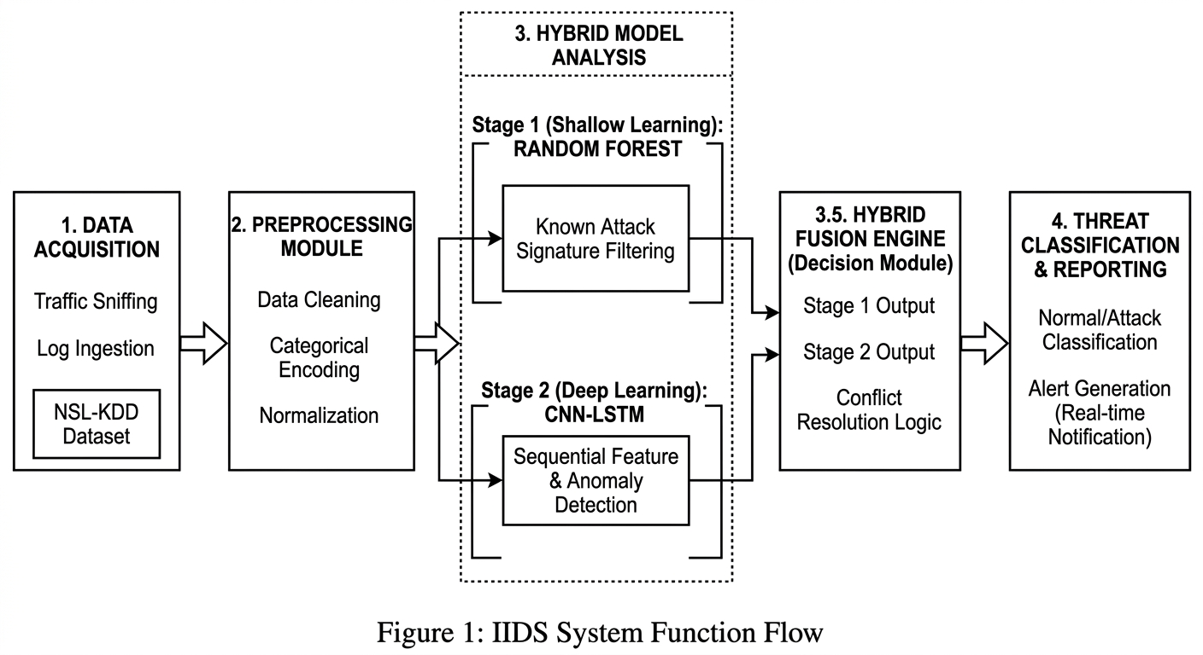
Figure 1 : IIDS System Function Flow

3.3 User Characteristics
The system is designed for two primary categories of users:
  - Network Administrator (Admin):
The Network Administrator is a technical user responsible for managing and maintaining the Intelligent Intrusion Detection System (IIDS). The administrator has full system privileges, including configuring system settings, managing user access, uploading network traffic datasets, and monitoring real-time alerts. The admin is expected to possess a basic understanding of networking concepts such as TCP/IP protocols, network traffic behavior, and cybersecurity fundamentals. Additionally, the administrator is responsible for ensuring system availability, reviewing detection results, and taking necessary actions when malicious activities are identified. The administrator plays a critical role in maintaining the security and operational stability of the system.
  - Security Analyst:
In the Intelligent Intrusion Detection System (IIDS), the Security Analyst serves as the primary expert user responsible for performing deep forensic investigations and validating the system’s findings. While the hybrid machine learning engine automates the initial detection of threats like DoS, Probe, or R2L attacks, the analyst is required to interpret the "Confidence Scores" and detailed attack logs to distinguish between genuine security breaches and harmless false positives. This "human-in-the-loop" approach ensures that the system’s 92% accuracy target is supported by expert oversight, particularly when the unsupervised model flags a zero-day anomaly that lacks a known signature. Beyond simple monitoring, the Security Analyst plays a strategic role in incident response and long-term system maintenance. This role is distinct from the Network Administrator, who focuses on the operational health and configuration of the host server; the Security Analyst is strictly focused on the forensic integrity of the network and ensuring that the detection thresholds are tuned to minimize administrative fatigue while maximizing security coverage.
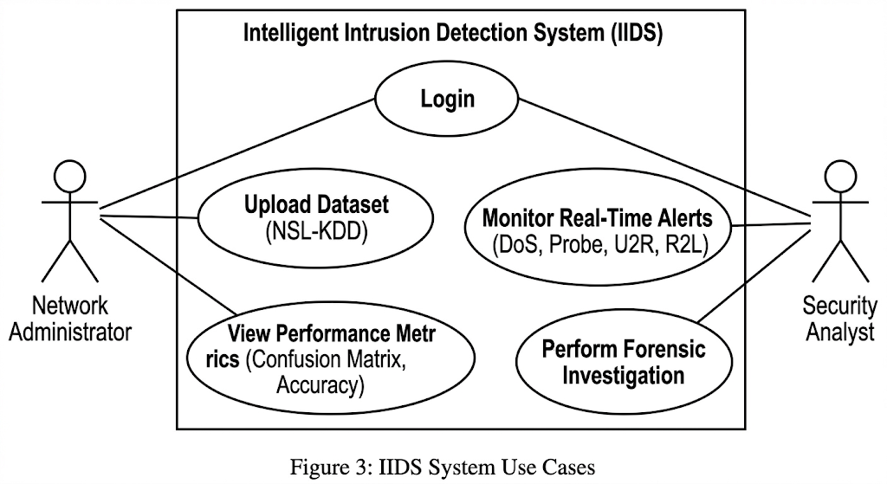
Figure 2: IIDS System Use Cases

3.4 General Constraints
The general constraints for the Intelligent Intrusion Detection System (IIDS) define the technical and operational boundaries within which the system must function. These limitations are critical for setting realistic performance expectations and ensuring hardware compatibility.
1. Hardware and Resource Dependencies
The most significant constraint is the system's reliance on specific computational resources for its deep learning components.
- GPU Mandate: The Deep Learning training module is strictly dependent on NVIDIA CUDA libraries.
- Architecture Limitations: The model cannot be trained effectively on AMD GPUs or standard CPUs without extensive code modification.
- Processing Overhead: While the Random Forest module provides near-instant filtering, the Deep Learning module (CNN-LSTM) may introduce slight processing latency during periods of high-volume network traffic.
2. Data and Structural Rigidity
The system is designed with a high degree of specialization for the selected research environment.
- Dataset Specificity: The IIDS is hard-coded to accept the NSL-KDD feature set, which consists of exactly 41 columns.
- Input Constraints: The system cannot ingest raw PCAP (Wireshark) files directly; it requires an external conversion tool to format data into the supported KDD structure.
- Environment Sensitivity: Because it is trained specifically on the NSL-KDD dataset, the system may require significant re-training to remain effective in different network environments, such as IoT or enterprise-specific networks.
3. Operational and Interface Boundaries
There are also constraints regarding how the system interacts with users and the existing network infrastructure.
- Passive Defense: The system is strictly a Passive Monitoring System; it does not have the authority to automatically block IP addresses or take "Active Defense" actions.
- Protocol Limitations: Currently, the IIDS is designed for IPv4 traffic analysis and does not support the IPv6 protocol.
- Browser Compatibility: The administrator dashboard utilizes modern CSS Grid layouts, meaning it will not render correctly on legacy browsers like Internet Explorer.
4. Security and Performance Targets
To maintain operational integrity, the system must adhere to strict internal security and performance goals.
- Latency Threshold: The system must process packets and generate a prediction in less than 200 milliseconds using the optimized Random Forest filter.
- Accuracy Floor: The hybrid model must maintain a minimum classification accuracy of 92% to be considered reliable.
- Access Control: All administrative access is constrained by a login requirement utilizing SHA-256 hashed passwords to ensure credentials are not stored in plain text.

3.5 Assumptions
Assumptions are conditions considered true for the successful development and operation of the system.
Technical Assumptions
  - The deployment environment will support required software frameworks (e.g., Python/Java runtime, ML libraries).
  - The hosting server will meet minimum hardware requirements (adequate CPU, RAM, storage).
  - The network infrastructure will provide stable internet connectivity.
  - Required ports for HTTP/HTTPS communication will be open and accessible.
  - External APIs (if used) will remain available and stable.
Data-Related Assumptions
  - Input data (network traffic, system logs) will be available in structured or standard formats.
  - Historical datasets required for ML model training will be accessible.
  - Input data will be legally and ethically collected.
  - Data volume will remain within manageable processing limits.
  - Feature formats used for ML training will remain consistent during deployment.
Security Assumptions
  - Users will follow strong password policies.
  - Encryption standards used (TLS, AES) will remain secure during system lifecycle.
  - Authorized administrators will manage system credentials securely.
  - No insider threats beyond defined access control levels.
Operational Assumptions
  - System administrators are technically trained to operate and monitor the system.
  - Users will access the system through supported browsers or approved clients.
  - Regular system maintenance and updates will be performed.
  - Backup mechanisms will be regularly monitored and tested.

3.6 Dependencies
Dependencies are external factors or systems that the project relies upon for proper functioning.
Software Dependencies
  - Machine Learning libraries (e.g., Scikit-learn, TensorFlow, PyTorch).
  - Database management system (e.g., MySQL, PostgreSQL, MongoDB).
  - Web framework for API services (e.g., Flask, Spring Boot, Node.js).
  - Operating system compatibility (Linux/Windows server).
Hardware Dependencies
  - Server infrastructure for hosting the detection system.
  - Network monitoring devices or log-generating systems.
  - Secure storage for logs and datasets.
Network Dependencies
  - Reliable network connectivity for real-time monitoring.
  - HTTPS protocol availability for secure communication.
  - Firewall and router configurations permitting required traffic.
External Service Dependencies
  - Third-party threat intelligence feeds (if integrated).
  - Email/SMS gateway for alert notifications.
  - External monitoring or SIEM systems (if integrated).
Regulatory / Compliance Dependencies
  - Compliance with organizational security policies.
  - Adherence to data protection regulations (if applicable).
  - Institutional approval for monitoring network traffic.

4. Specific Requirements

4.1 External Interface Requirements

4.1.1 User Interfaces
The system shall provide a web-based Graphical User Interface (GUI) accessible via standard web browsers (Chrome, Edge, Firefox).

  - Dashboard: A central view displaying real-time attack statistics (Pie Charts/Bar Graphs).
  - Alert Panel: A scrolling list of detected threats with timestamps and IP details.
  - Login Screen: A secure authentication page for the Network Administrator.

4.1.2 Hardware Interfaces
The system interacts with the host hardware to utilize computational resources efficiently.
  - Processor: Minimum Intel Core i5 or AMD Ryzen 5 (AVX2 instruction set support required).
  - Memory: Minimum 8GB RAM (16GB Recommended for model training).
  - GPU: NVIDIA GPU with CUDA Core support (Minimum 4GB VRAM) is required for the Deep Learning training module.
  - Storage: Minimum 10GB free space for the NSL-KDD dataset and log archives.

4.1.3 Software Interfaces
• Operating System: Windows 10/11 or Linux (Ubuntu 20.04+).
• Backend Framework: Python 3.9+ using Flask/Django.
• Machine Learning Libraries: TensorFlow 2.x, Scikit-Learn, Pandas, NumPy.
• Database: Local CSV file system for dataset storage; SQLite for user credentials.

4.1.4 Communications Interfaces
• Protocol: The system shall operate using TCP/IP protocols for reading network log data.
• Format: Input data must be formatted as Comma Separated Values (CSV) adhering to the KDD structure.

4.2 Functional Requirements

Functional Requirements (Hybrid Detection Flow Based):

4.2.1 Network Traffic Input Acquisition
The system shall capture and receive network traffic data from monitored network environments for intrusion analysis.
The system shall collect real-time network traffic data including:
- Packet headers
- Source and destination IP addresses
- Port numbers
- Protocol type
- Connection duration
- Payload metadata (if applicable)
The system shall support:
- Live packet capture
- Log file ingestion
- API-based input from external monitoring tools
The system shall ensure:
- Only authorized network sources are allowed to send data.
- All input data is timestamped upon arrival.
- Duplicate entries are identified and filtered.
The system shall handle high-volume traffic without data loss.

4.2.2 Data Validation and Preprocessing
The system shall validate and preprocess raw input data before feeding it into machine learning models.
The system shall validate:
- Data format correctness (JSON, CSV, structured logs)
- Presence of mandatory fields
- Valid IP and protocol formats
The system shall reject malformed or corrupted input.
Additionally, the system shall perform preprocessing steps including:
- Feature normalization
- Encoding categorical variables
- Removing redundant attributes
- Handling missing values
- Noise filtering
The system shall extract relevant features required for ML model input.
The preprocessing module shall ensure consistency between training and testing data formats.

4.2.3 Supervised Model Processing
The system shall analyze preprocessed data using a trained supervised machine learning model.
The supervised model shall:
- Be trained on labelled intrusion datasets.
- Classify traffic as intrusion or normal based on learned patterns.
- Generate prediction confidence scores.
The system shall allow:
- Periodic retraining of the supervised model.
- Updating the model without system downtime.
The system shall log prediction results along with probability scores.
The supervised model shall achieve predefined minimum accuracy thresholds.

4.2.4 Unsupervised Model Processing
The system shall analyze traffic using an unsupervised model to detect unknown or anomalous behaviors.
The unsupervised model shall:
- Identify deviations from normal traffic patterns.
- Detect zero-day or unknown attack patterns.
- Assign anomaly scores to each input instance.
The system shall allow threshold configuration for anomaly detection.
The model shall operate in parallel with the supervised model.
Anomaly detection results shall be forwarded to the decision module.

4.2.5 Decision Module (Hybrid Fusion Engine)
The decision module shall combine outputs from supervised and unsupervised models to produce the final classification.
The system shall:
- Aggregate prediction results from both models.
- Apply fusion logic (e.g., voting, weighted scoring, threshold-based logic).
- Resolve conflicts between model outputs.
The final output shall be:
- Intrusion
- Normal
The system shall record:
- Individual model outputs
- Final decision
- Decision reasoning (if applicable)
The decision logic shall be configurable by administrators.
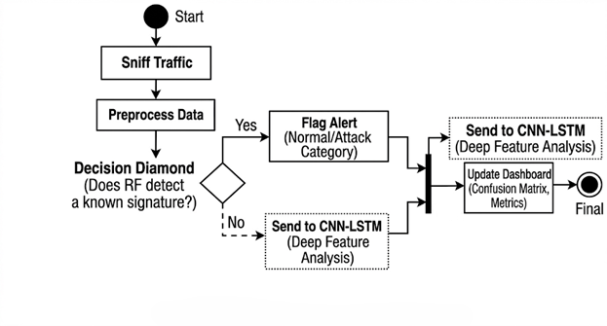
Figure 3: IIDS Hybrid Logic Activity Flow

4.2.6 Logging & Auditing
The system shall log all detection events, processing stages, and administrative activities.
The system shall log:
- Raw input metadata
- Preprocessing actions
- Supervised model predictions
- Unsupervised anomaly scores
- Final decision result
- Timestamp
- Source IP
- Severity level
Logs shall be:
- Stored in secure append-only format
- Protected from unauthorized modification
- Encrypted at rest
The system shall maintain audit trails for:
- Configuration changes
- Model updates
- User login attempts
Log retention period shall be configurable.

4.2.7 Alert & Notification Management
The system shall generate alerts when an intrusion is detected. The system shall:
- Trigger real-time alerts for intrusion events.
- Assign severity levels (Low, Medium, High, Critical).
- Notify administrators via dashboard.
- The system may support:
    - Email notification
    - SMS notification
    - API-based alert forwarding
Alerts shall include:
- Event timestamp
- Source & destination information
- Type of intrusion detected
- Confidence/anomaly score
Repeated alerts from the same source shall be grouped to prevent alert flooding.

4.3 Non-Functional Requirements

4.3.1 Performance Requirements
• Detection Latency: The system shall process a single network packet and generate a prediction in less than 200 milliseconds using the optimized Random Forest filter.
• Training Time: The Deep Learning model (CNN) shall be capable of completing one training epoch on the NSL-KDD dataset (approx. 125,000 records) in under 5 minutes when utilizing an NVIDIA RTX GPU.
• Throughput: The dashboard shall update the live traffic table every 2 seconds to reflect real-time network status.

4.3.2 Reliability and Availability
• Accuracy Target: The Hybrid Model shall achieve a minimum classification accuracy of 92% on the test dataset.
• False Positive Rate: The system shall aim to keep the False Positive Rate (Normal traffic flagged as Attack) below 5% to prevent administrative fatigue.
• Availability: The system is designed to run 24/7. In the event of a crash, the Flask server must auto-restart within 30 seconds.

4.3.3 Security Requirements
• Access Control: The Admin Dashboard shall be protected by a login page requiring a valid username and SHA-256 hashed password.
• Data Integrity: The original NSL-KDD dataset files must be read-only to prevent accidental corruption during the training phase.

4.3.4 Maintainability
• Modular Code: The Python code shall be structured into separate folders (/model, /api, /frontend) to allow independent updates.
• Logging: The system shall maintain a system.log file to record internal errors (e.g., "Memory Error", "File Not Found").

